

SIMATS ENGINEERING

Saveetha Institute of Medical and Technical Sciences
Chennai- 602105

Student Name:B.Yogesh ramu Reg. No :192572178
Course Code: CSA0764 Slot: A
Course Name: COMPUTER NETWORKS FOR A GAME SERVER
Course Faculty: DR.Senthil, DR.Rajaram
Project Title : “Development Of An Encrypted Email Transmission System Using SMTP Over SSl/TlS”

Module Photographs: The PPT Presentation Photo Of My Capstone Project And My Model Chart Work Of My Capstone Project
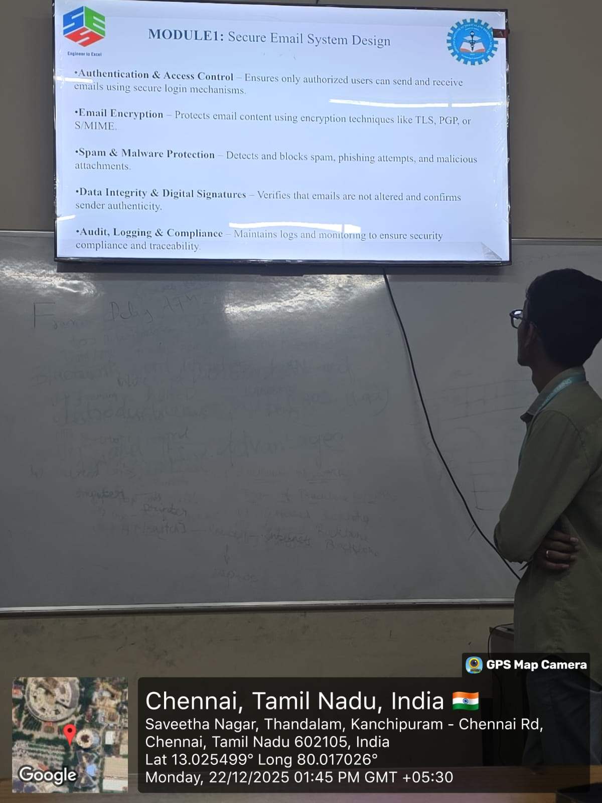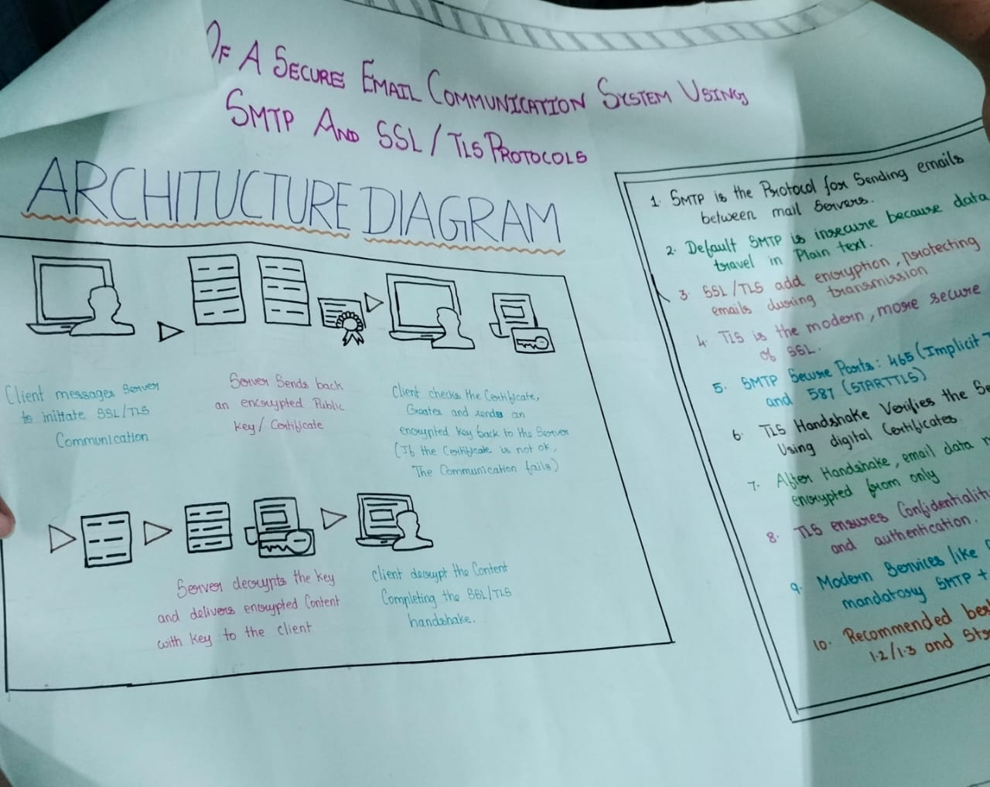
Project Description: This project focuses on developing a secure email transmission system by implementing SMTP over SSL/TLS to protect email data during communication
Project Title :”Development Of An Encrypted Email Transmission System Using Smtp Over SSl/TlS”
Objective : through the project “Development of an Encrypted Email Transmission System Using SMTP over SSL/TLS”, I gained a clear understanding of how email communication works and how security is applied in real-world systems. I learned the basic working of the Simple Mail Transfer Protocol (SMTP) and how emails are sent from a client to a mail server and then to the receiver. This project helped me understand why traditional SMTP is insecure and how data can be exposed if encryption is not used.I learned the importance of SSL (Secure Sockets Layer) and TLS (Transport Layer Security) in protecting data during transmission. I understood how SSL/TLS creates a secure communication channel using encryption, authentication, and integrity checks. The concept of the SSL/TLS handshake process, certificate verification, and key exchange became clear through this project. This project also helped me learn about network security concepts such as encryption, secure authentication, data confidentiality, and protection against cyberattacks like eavesdropping and man-in-the-middle attacks. I understood how user credentials and email content can be safely transmitted over the internet.

Student Signature Guide Signature

